**Binary Search Variations**

1. Classic Binary Search.

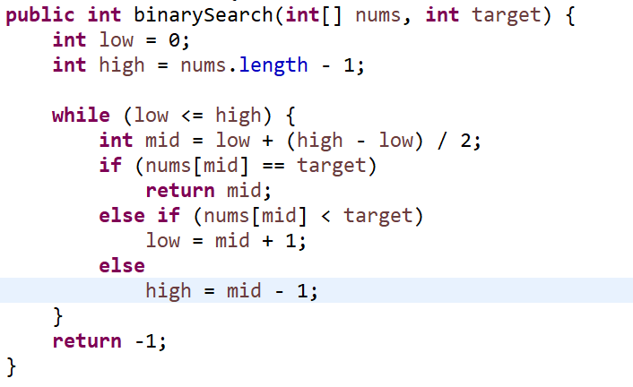

1. **Finds the first position where the target could be inserted without violating the order.**

- 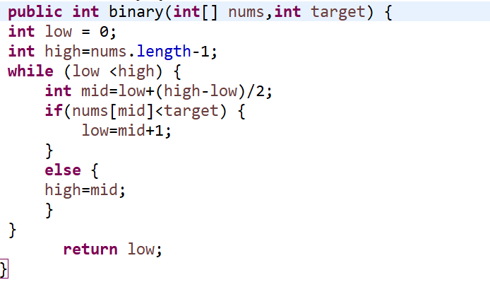

1. **Find index of smallest element greater than the target appears.**

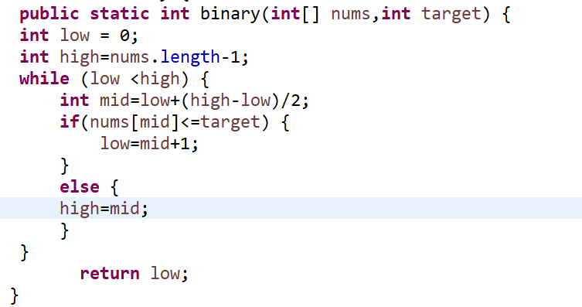

1. **This is to find greatest less than target.**(Finds the index of the greatest element less than the target.)

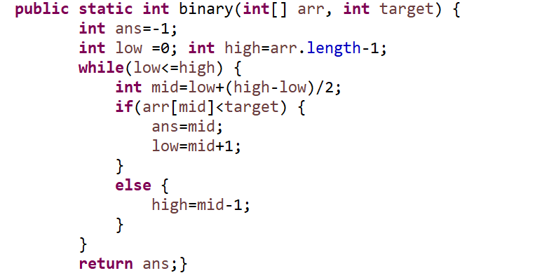

1. **Search Insert Position(**Finds the index at which a target value should be inserted to maintain the sorted order).

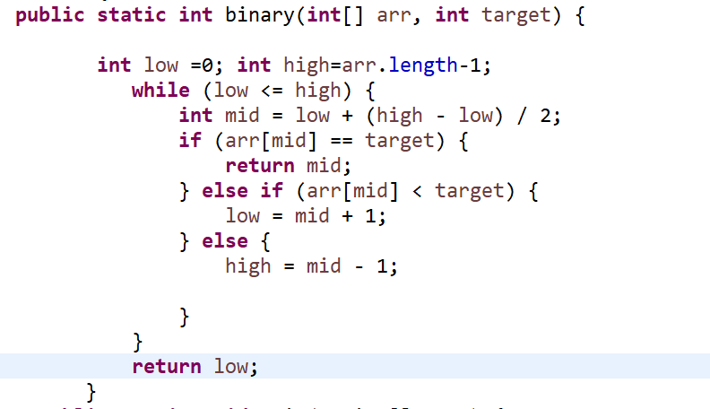

1. **Find Upper Bound of a element(target element last position ).**

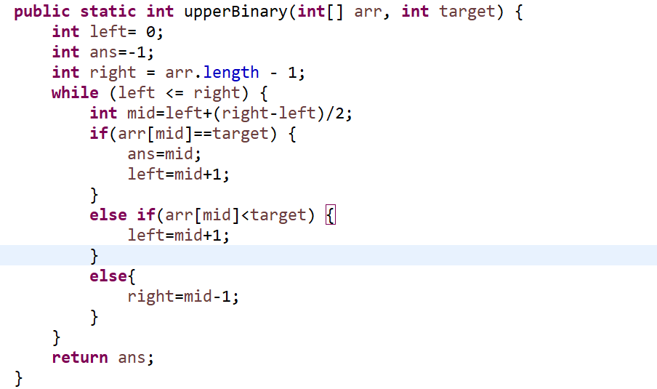

1. **Find Lower Bound of an element(target element first position ).**

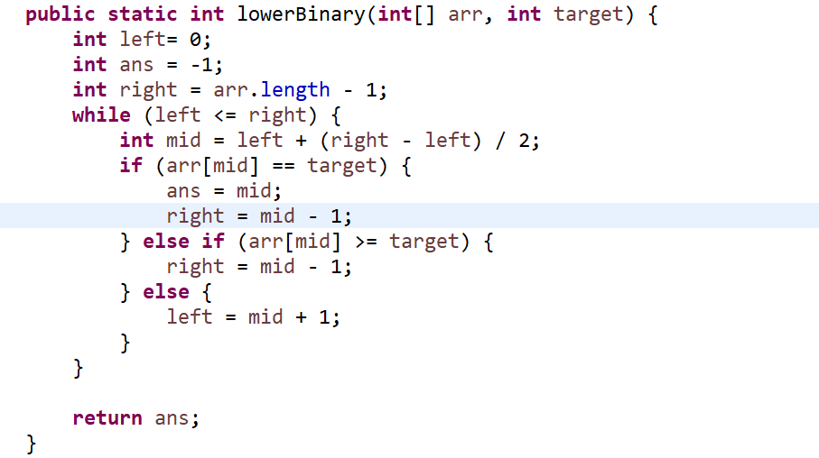

1. **Find Minimum in a Rotated Sorted Array.(**Finds the minimum element in a rotated sorted array**.)**

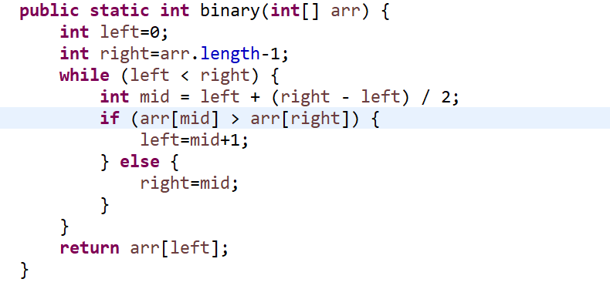

1. **Search in Rotated Sorted Array.**(Searches for a target value in a rotated sorted array).